To test traffic for Lab 7b:

Both students should do these pings at the same time.

If you are running RTR1:
a) From the laptop in network 200.100.10.0:
i. ping -t 192.168.20.2 (SW3)
ii. ping -t 192.168.21.2 (SW4)
iii. ping -t 10.10.10.2
b) From the laptop in Network 192.168.11.0
i. ping -t 192.168.20.2 (SW3)
ii. ping -t 192.168.21.2 (SW4)
iii. ping -t 10.10.10.2 (RTR1)

If you are running RTR2:
a) From the laptop in network 192.168.20.0:
i. ping -t 200.100.10.2 (SW1)
ii. ping -t 192.168.11.2 (SW2)
iii. ping -t 10.10.10.1 (RTR1)
a) From the laptop in network 192.168.21.0:
i. ping -t 200.100.10.2 (SW1)
ii. ping -t 192.168.11.2 (SW2)
iii. ping -t 10.10.10.1 (RTR1)

If you have done the above, you now have continuous traffic on the serial link. We might even have some congestion. Now we will test policing of traffic.

RTR1 student:
a) Enable the TFTP server on the laptop on network 192.168.11.0.
i.) The program is tftpd64, and you must run it as an administrator.
b) On SW1, issue the command dir flash:
i. This will show you the directory where your IOS is. Example: on my switch, I can see the directory of the ios file “c3750e-universalk9-mz.150-2.SE7”. I then look in that directory for the bin file “c3750e-universalk9-mz.150-2.SE7.bin”
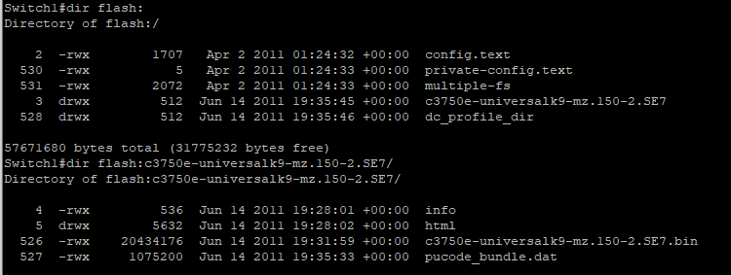
c) Once you have determined the .bin filename and location, issue the following command on SW1 (I used my info, adjust yours as required) to copy the bin file to the tftp server on the 192.168.21.0 network
Switch1#copy flash:/c3750e-universalk9-mz.150-2.SE7/c3750e-universalk9-mz.150-2.SE7.bin tftp
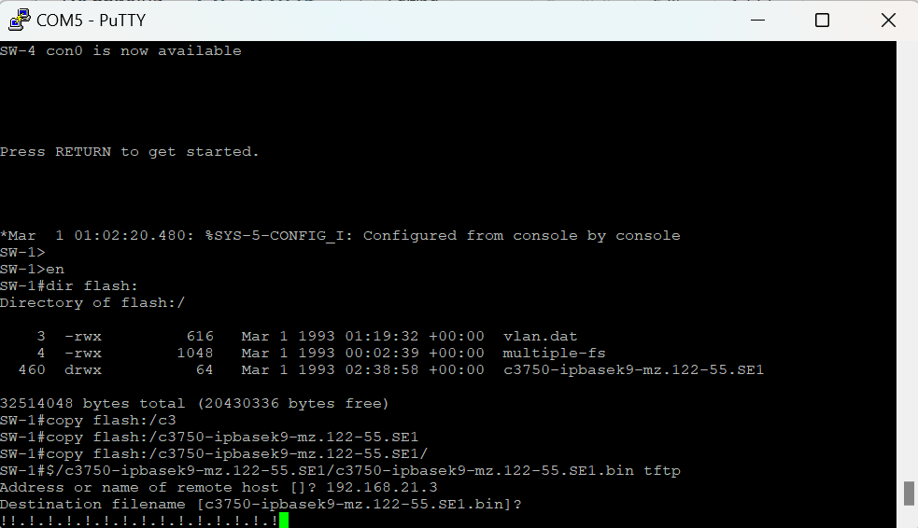

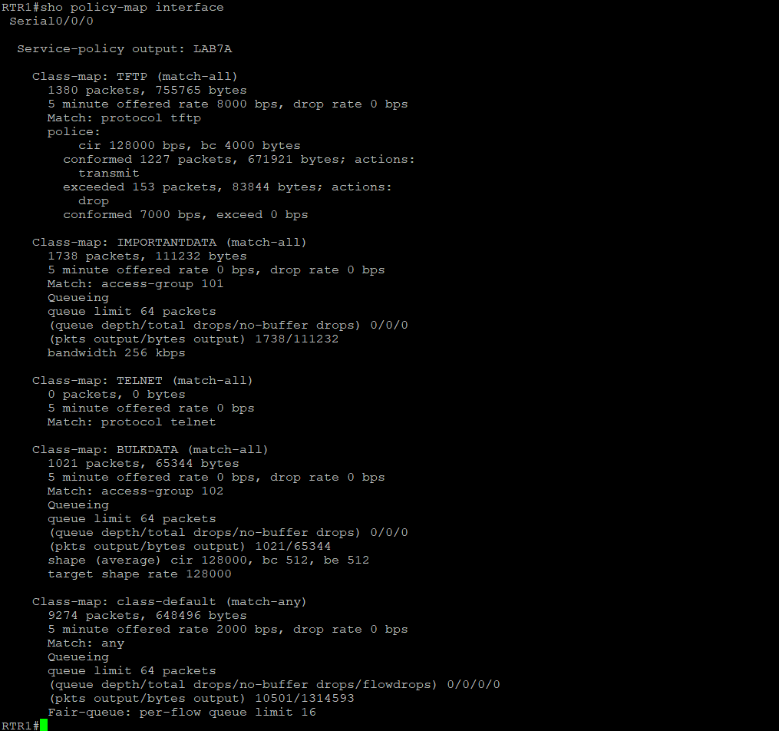
RTR2 student:
a) Enable the TFTP server on the laptop on network 192.168.21.0.
i.) The program is tftpd64, and you must run it as an administrator.
b) Follow the steps above to copy your bin file to the TFTP server on the 192.168.11.0 network.

You should see that the packets are policed. Issue the show policy-map interface. Paste the output at the end of your lab.

